Artificial Intelligence Lab

Lab 6: NLP Fundamentals
Tokenization, Embeddings & Text Chunking (Task 1 and Task 2)

Field | Detail
Name | Amina Mustafa
Roll number | 329

Task 1 (Beginner) - Part A: Tokenization

1. Objective
Compare whitespace splitting with a Unicode word-like regular expression on six inputs (punctuation, a contraction, an email, CS4944, an empty string and Urdu text), print the original text, token lists and counts, explain two differences and one normalization risk, and try the model tokenizer where available.

2. Explanation
- Whitespace splitting (text.split()) cuts the string at spaces. It is fast and keeps identifiers such as CS4944 intact, but punctuation stays attached to words ("AI," and "search!").
- Unicode word-like regex (re.findall(r"\b\w+\b", text)) extracts runs of letters and digits. It removes punctuation, but it also splits contractions and email addresses. It is not a linguistic tokenizer.
- Model sub-word tokenizer (the tokenizer of all-MiniLM-L6-v2) has its own vocabulary and may split a single word into several pieces, so its token count can differ from both methods above. This is the count that matters for the encoder's input limit of 256 word pieces.
- Conservative normalization: the original text is kept untouched for reporting; any lower-cased or cleaned copy is made separately and only for searching.

3. What the program does
task1_tokens.py loops over the six inputs, prints the original with repr(), then both token lists and their counts. It asserts that the regex gives an empty list for an empty string. A second block demonstrates a normalization risk. A third block tries to load the model tokenizer for the first two English inputs and reports clearly if that is not possible.

4. Observed results (from the actual run)
Input type | Original | Whitespace count | Word-like regex tokens | Regex count
Punctuation | AI, search! | 2 | AI, search | 2
Contraction | I can't log in. | 4 | I, can, t, log, in | 5
Email | help@example.com | 1 | help, example, com | 3
Course code | CS4944 | 1 | CS4944 | 1
Empty string | (empty) | 0 | (none) | 0
Urdu text | یہ ایک مثال ہے | 4 | 4 Urdu words | 4

Two differences
- Contraction: whitespace gives 4 units for "I can't log in." (can't stays whole, in. keeps its full stop), but the regex gives 5 units because the apostrophe splits can't into can and t, and the full stop is dropped.
- Email: whitespace keeps help@example.com as 1 unit, while the regex breaks it into help, example and com (3 units). The email is no longer a single searchable identifier. For punctuation, "AI, search!" has the same count (2) in both methods, but whitespace keeps the comma and exclamation mark attached to the words.

One normalization risk
If we lower-case, split with the regex and then drop one-letter tokens as noise, "I can't log in." becomes can, log, in. The leftover t was the negation, so a system would read the sentence as I CAN log in, which reverses the meaning. Case-sensitive identifiers (CS4944) and emails can be damaged in the same way, so the original text must always be preserved and normalization should be limited to a separate search copy.

Urdu text and limits of the regex
For this short Urdu sentence both methods give four tokens, because the words are separated by spaces and Urdu letters count as word characters (\w). This does not make the regex a complete multilingual tokenizer: it does not know about Urdu morphology, joiner characters or languages written without spaces, and English-only model results say nothing about Urdu retrieval quality.

Model tokenizer
Not run. The program printed: Model tokenizer NOT run: ModuleNotFoundError - No module named 'sentence_transformers'. When the package is installed, the same script prints the sub-word list for two English examples; those lists must be recorded as observed, not predicted.

5. Python code and output
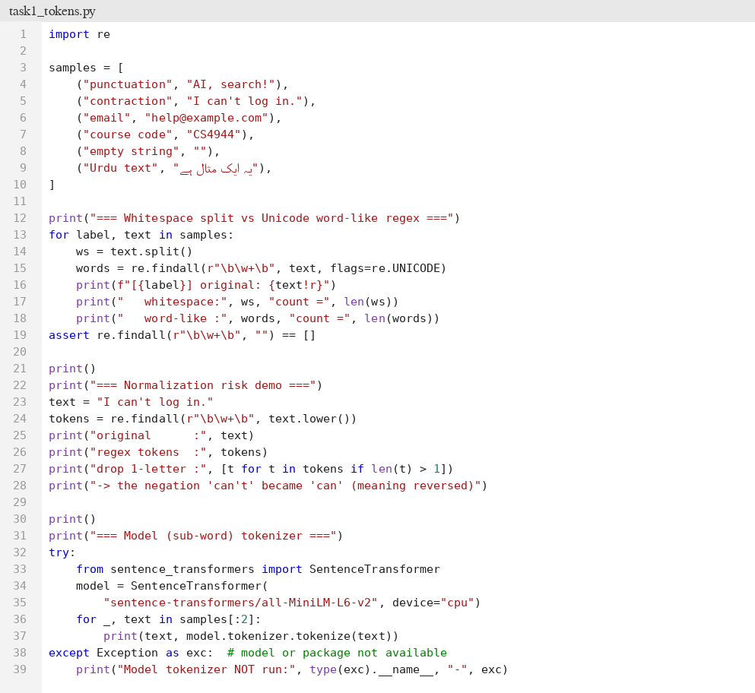
Figure 1: task1_tokens.py - source code
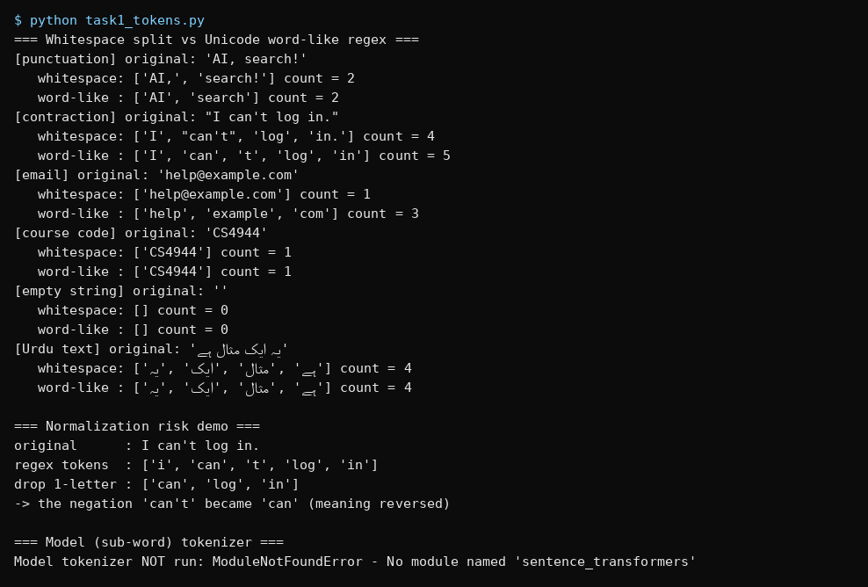
Figure 2: task1_tokens.py - terminal output

Task 1 (Beginner) - Part B: FAQ Chatbot

1. Objective
Run guided_chatbot.py with the TF-IDF backend, add two FAQs (each with a source), capture one exact answer, one suggestion response and one empty/unsupported input, and explain why the chatbot asks for confirmation on non-exact questions.

2. Explanation
The chatbot is a retrieval chatbot, not a generative model, and it has no conversation memory. Each FAQ record stores a canonical question, an answer and a source file. For each user input the bot works as follows:
- Empty input: it asks the user to enter a question.
- Exact canonical question (case-insensitive): it returns the stored answer together with its source, for example [source: it_help.txt].
- Any other question: TF-IDF compares the query with every FAQ (question + answer text) using cosine similarity and shows the top three candidate questions with their similarity, asking the user to choose or rephrase.
- No shared vocabulary at all (TF-IDF score of zero for every record): it says that no FAQ matches and tells the user to contact the help desk.

3. Two FAQs added (synthetic data)
ID | Question | Answer | Source
faq:wifi | How do I connect to the campus Wi-Fi? | Select CampusNet and sign in with your student ID and portal password. | it_help.txt
faq:library | When does the library open? | The library is open from 8 am to 8 pm on weekdays. | library_rules.txt

4. Captured results (from the actual run)
Case | User input | Bot response
Exact answer | How do I reset my password? | Use the recovery link on the login page. [source: it_help.txt]
Exact answer (added FAQ) | when does the library open? | The library is open from 8 am to 8 pm on weekdays. [source: library_rules.txt]
Suggestion response | password recovery | Possible matches: How do I reset my password? (0.422); How do I connect to the campus Wi-Fi? (0.118); Where do I submit my assignment? (0.000)
Suggestion, two topics | wifi password for my laptop | Possible matches: How do I reset my password? (0.375); Where do I submit my assignment? (0.161); How do I connect to the campus Wi-Fi? (0.132)
Empty input | (nothing) | Please enter a question.
Unsupported input | volcano geology | No matching FAQ. Please contact the help desk.

The reference assertions in task1_chatbot_check.py also passed: FAQ behaviour checks passed (exact answer contains the source, empty input is handled, an unsupported query gives the fallback, and a paraphrase gives Possible matches).

5. Why the chatbot asks for confirmation on non-exact questions
A similarity score is only a number that measures word overlap here; it is not a probability and does not prove that an FAQ answers the question. The run shows this clearly: for "wifi password for my laptop" the top suggestion was the password-reset FAQ (0.375) and the Wi-Fi FAQ came only third (0.132). The user wrote wifi, but the FAQ contains Wi-Fi, which the TF-IDF tokenizer splits into wi and fi, so the two words never match; the Wi-Fi FAQ scored only because of the shared word password. If the bot had answered automatically it would have given a wrong answer with confidence. By showing candidates and asking the user to pick or ask the canonical question, the bot only ever returns stored text that the user has confirmed, and it never presents a similarity score as proof of answerability.

6. Python code and output

Figure 3: guided_chatbot.py - source code (two FAQs added) (part 1 of 2)

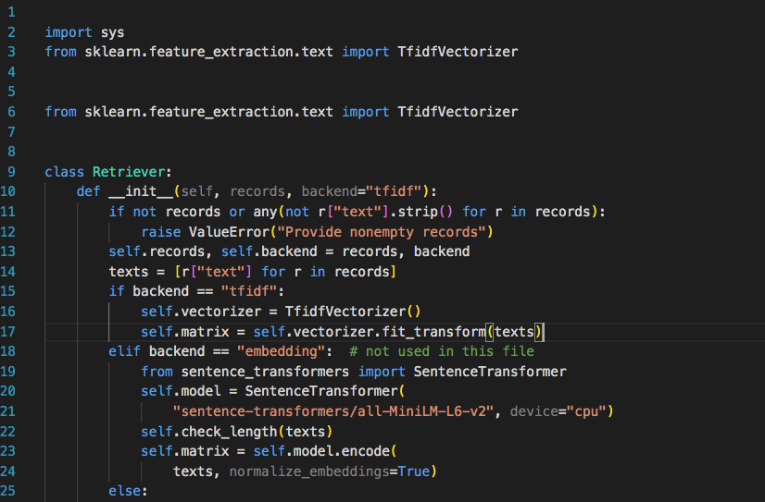
Figure 5: task1_chatbot_demo.py - script that sends the test inputs through reply()
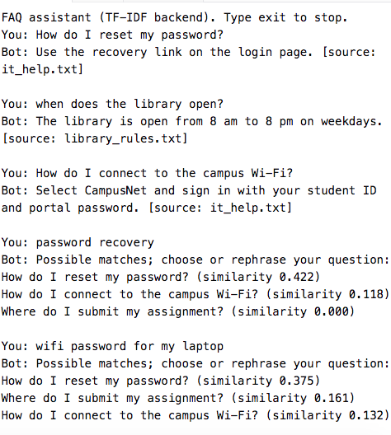

Task 2 (Intermediate) - Chunking and Semantic Suggestions

1. Objective
Build chunking functions with source offsets, compare 40-word windows (overlap 0 and 10) with sentence-aware packing (40-word budget) on a synthetic corpus, test edge cases, explain where sentence splitting fails, and compare paraphrased queries using TF-IDF and the sentence-embedding backend.

2. Explanation
- Why chunk: a long document cannot be stored or encoded as a single piece (the encoder has a 256 word-piece limit) and retrieval works better on focused passages. But if a rule and its exception end up in different chunks, a retrieved chunk can look correct while omitting the exception.
- Fixed word window: every chunk has at most 40 whitespace words; with overlap 10 each new window starts 30 words after the previous one, so 10 words are repeated. Boundaries ignore sentence structure.
- Sentence-aware packing: splits at sentence ends and packs whole sentences until the 40-word budget would be exceeded. A sentence longer than the budget is split by a fallback word window.
- Source metadata: each chunk stores a chunk ID (doc:index), document ID and character start/end, so chunk text always equals source[start:end]. The program asserts this for every chunk.
- Semantic suggestions: an embedding model maps text to dense vectors so that a paraphrase such as "regain access to my account" can be close to a "reset a forgotten password" passage without shared words; TF-IDF can only match shared words.

3. Corpus and labels
Three synthetic documents of 150-250 words were written. Each contains a rule with an exception, and the handbook (longest sentence 65 words) and the library document (50 words) contain sentences longer than the 40-word budget. The handbook also contains the abbreviations Dr. and e.g. to test the sentence splitter. For each document the rule + exception text was labeled before any chunking was run (exact substring of the document).
Document | Words | Evidence words | Labeled rule + exception
handbook | 172 | 37 | Late submission is normally penalized by ten percent for each day after the deadline. Illness extensions require medical evidence before the deadline, and the coordinator will not accept a certificate that is dated after the missed submission.
it_help | 173 | 28 | Reset a forgotten password using the recovery link on the login page. Accounts locked after five failed attempts cannot use the link and must visit the IT desk.
library | 183 | 40 | Borrowed books can be renewed once online unless another student has reserved them. Overdue books are fined at ten rupees per day, but the fine is waived for the first three days if the student has a valid medical certificate.

4. Chunk comparison (actual results)
Strategy | Chunks | Avg words | Min | Max | Repeated (duplicate) words
Window, size 40, overlap 0 | 15 | 35.2 | 12 | 40 | 0
Window, size 40, overlap 10 | 18 | 37.7 | 22 | 40 | 150
Sentence-aware, budget 40 | 18 | 29.3 | 10 | 40 | 0
The corpus has 528 original words. Duplicate words = total words emitted by all chunks minus original words. All chunks passed the offset check (chunk text equals the source substring).

Does each labeled rule + exception survive in one chunk?
Strategy | handbook | it_help | library | Survived
Window, overlap 0 | NO | YES | NO | 1 / 3
Window, overlap 10 | NO | YES | NO | 1 / 3
Sentence-aware | YES | YES | NO | 2 / 3

Interpretation
- Sentence-aware packing kept the most evidence intact (2 of 3) with no duplicated text, but it produced the smallest average chunk (29.3 words) and as many chunks as overlap 10.
- Overlap 10 added 3 chunks and 150 repeated words (about 28% extra text compared with 528 original words) and did not rescue any extra rule/exception in this corpus. The extra 10 words are not enough to repair a boundary in the wrong place.
- The library evidence (40 words) fails in every strategy. For windows it would have to start exactly at a window start. For sentence-aware packing, the greedy packer put the renewal sentence together with the earlier sentences (chunk library:0, characters 0-177), so the overdue-fine sentence started a new chunk and the rule and its exception were separated. Packing whole sentences is not the same as keeping a rule with its exception.
- With only three documents these are observations, not a general conclusion about which strategy is best.

Edge-case tests
Test | Result observed
Empty text | windows("") and sentence_chunks("") both return []
Document shorter than the budget | 4-word text gives one chunk, (0, 22), for both window and sentence-aware chunking
Invalid overlap / size | overlap 40 with size 40, overlap -1 and size 0 all raise ValueError (Require size > 0 and 0 <= overlap < size)
Sentence longer than the budget | 95-word sentence is split by the fallback into 3 chunks of 40, 40 and 15 words

Where sentence splitting fails
The teaching splitter treats any full stop, question mark or exclamation mark followed by whitespace as a sentence end. In the handbook this created false boundaries after the abbreviations "Dr." and "e.g." (the run printed both false sentence ends). The title Dr. is cut away from the name Khan, and the example introduced by e.g. is separated from the text that follows it. The same weakness applies to decimals with spaces, initials and numbered lists. The regex also contains only . ! and ?, so it would not recognize the Urdu full stop, and an Urdu document would be treated as one very long sentence and sent to the word-window fallback. Practical improvements: an abbreviation list, a trained sentence tokenizer (for example NLTK or spaCy), and a language-aware rule for Urdu.

5. Semantic suggestions: three paraphrased queries
Records were built from the 18 sentence-aware chunks (IDs such as handbook:1). The program runs the same three paraphrased queries first with the TF-IDF backend and then with the embedding backend, printing the top three chunk IDs, scores, character offsets and the original chunk text. A result is counted as relevant only if it is in the right document and the chunk contains the full labeled evidence.
Query (paraphrase) | Expected doc | TF-IDF top-1 result | Full evidence in top 3?
I was sick, can I hand in my work a day late? | handbook | handbook:1 (0.182) - the late rule and the illness exception | Yes, rank 1
How can I regain access to my account? | it_help | it_help:3 (0.319) - guest account text, not the password rule | No
Is there a charge when I return a book after the due date? | library | library:5 (0.213) - lost books and a processing charge | No

TF-IDF result on these three queries: Hit@3 = 1/3 = 0.333 and MRR@3 = 0.333 (first query at rank 1, other two misses). Three queries are far too few for a conclusion; they are used only to inspect behaviour.

Failure analysis
- Query 2: the password passage shares no words with "regain access to my account". TF-IDF picked it_help:3 only because both contain the word account (a guest account request). This is the "recover my account" problem from the lab's trigger questions: lexical matching misses a paraphrase with no shared keywords.
- Query 3: the question uses charge, return and due date, while the rule uses fined and overdue. TF-IDF matched charge in the lost-books sentence (library:5) and ranked a handbook chunk about late penalties second. The correct overdue-fine sentence did not reach the top three. In addition, the sentence-aware chunking had already separated that sentence from the renewal rule (see section 4), so no chunk could contain the full labeled evidence for this query.
- Query 1 succeeded because it shared the words late and day with the chunk, and because the sentence-aware chunk kept the rule and exception together. A high score still would not prove the passage is current or sufficient.

Embedding backend (guided_embeddings.py and guided_suggestions.py)
Not run. The embedding backend printed: Backend NOT run: ModuleNotFoundError - No module named 'sentence_transformers'. Because no embedding results were produced, no comparison between embeddings and TF-IDF is claimed in this report. When sentence-transformers and the model are available, python task2_semantic.py prints the embedding rankings below the TF-IDF ones, using the same chunks and queries, and the TF-IDF comparison above can then be completed with the observed scores. Semantic scores are not probabilities and usually stay non-zero even for unrelated questions, so a lexical rule such as hiding score 0 must not be transferred to embeddings.

6. Python code and output

task2_chunks.py - chunking functions



